NAME: HANAN KHAN
ENROLLMENT: 03-135232-024

LAB: CMS

Content Management Systems (CMS)

🧪 Lab Manual – Week 1

🔹 Lab Title
Introduction to CMS & WordPress Environment

🔹 Lab Duration
2–3 Hours

🔹 Lab Objectives
After completing this lab, students will be able to:
- Understand what a CMS is in practical terms
- Identify different CMS platforms
- Set up a local development environment
- Install WordPress successfully
- Access and explore the WordPress dashboard
- Understand basic CMS workflow (Login → Create → Publish)

🔹 Software / Tools Required
- Computer or Laptop
- Internet Browser (Chrome / Firefox)
- XAMPP or WAMP Server
- Latest WordPress package
- Text Editor (optional – Notepad++)

🔹 Basic Concepts (Quick Review)

What is CMS?
A CMS allows users to create and manage website content without coding.

What is WordPress?
- Open-source CMS
- Written in PHP
- Uses MySQL database
- Most widely used CMS in the world

🧪 Lab Task 1: Identify Popular CMS Platforms

Instructions:
- Open your browser
- Search for examples of CMS platforms
- Write names of at least 5 CMS platforms
• WordPress
• Joomla
• Drupal
• Magento (for e-commerce)
• Shopify (CMS + e-commerce

🧪 Lab Task 2: Install Local Server (XAMPP)

Step-by-Step Instructions:
- Go to https://www.apachefriends.org
- Download XAMPP for Windows
- Install XAMPP using default settings
- Open XAMPP Control Panel
- Start Apache and MySQL services
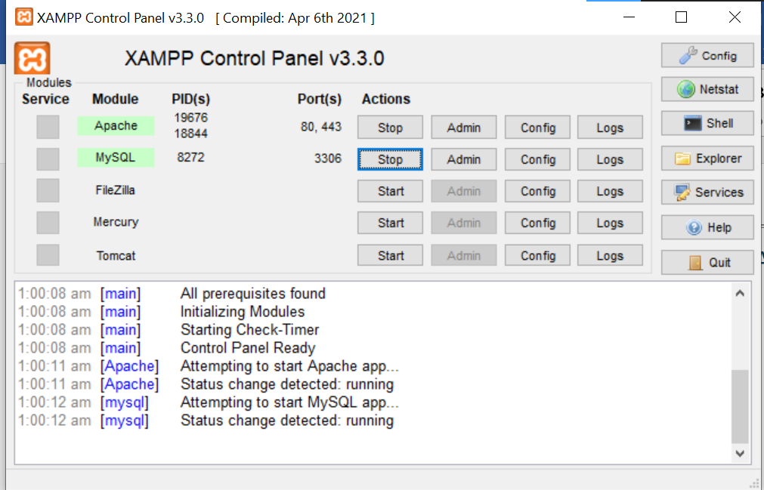

Verification:
- Open browser
- Type: http://localhost
- XAMPP dashboard should appear
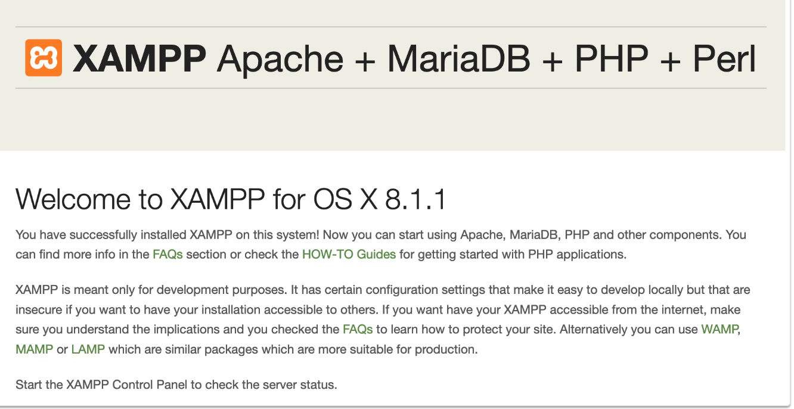

🧪 Lab Task 3: Download & Extract WordPress

Steps:
- Visit https://wordpress.org
- Download latest WordPress version
- Extract the ZIP file
- Copy the wordpress folder
- Paste it into: C:\xampp\htdocs
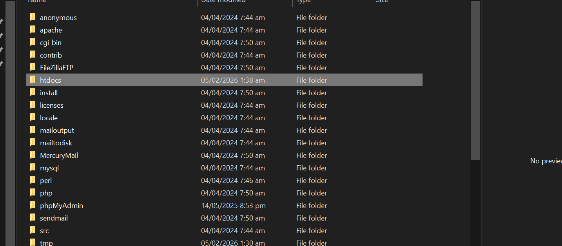
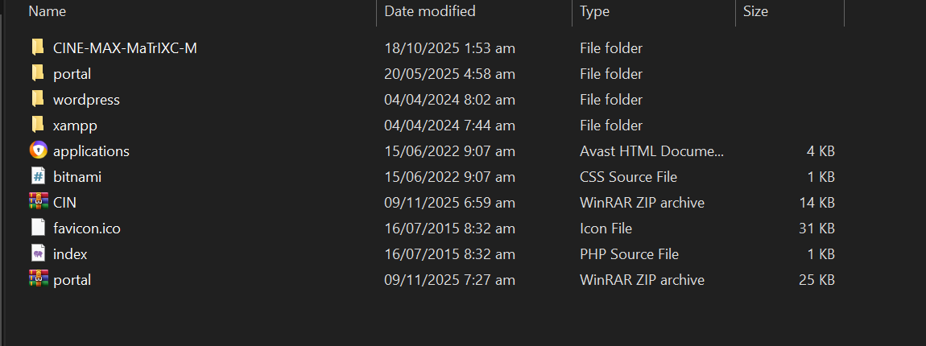

🧪 Lab Task 4: Create Database for WordPress

Steps:
- Open browser
- Go to: http://localhost/phpmyadmin
- Click New
- Database Name: cms_lab
- Click Create
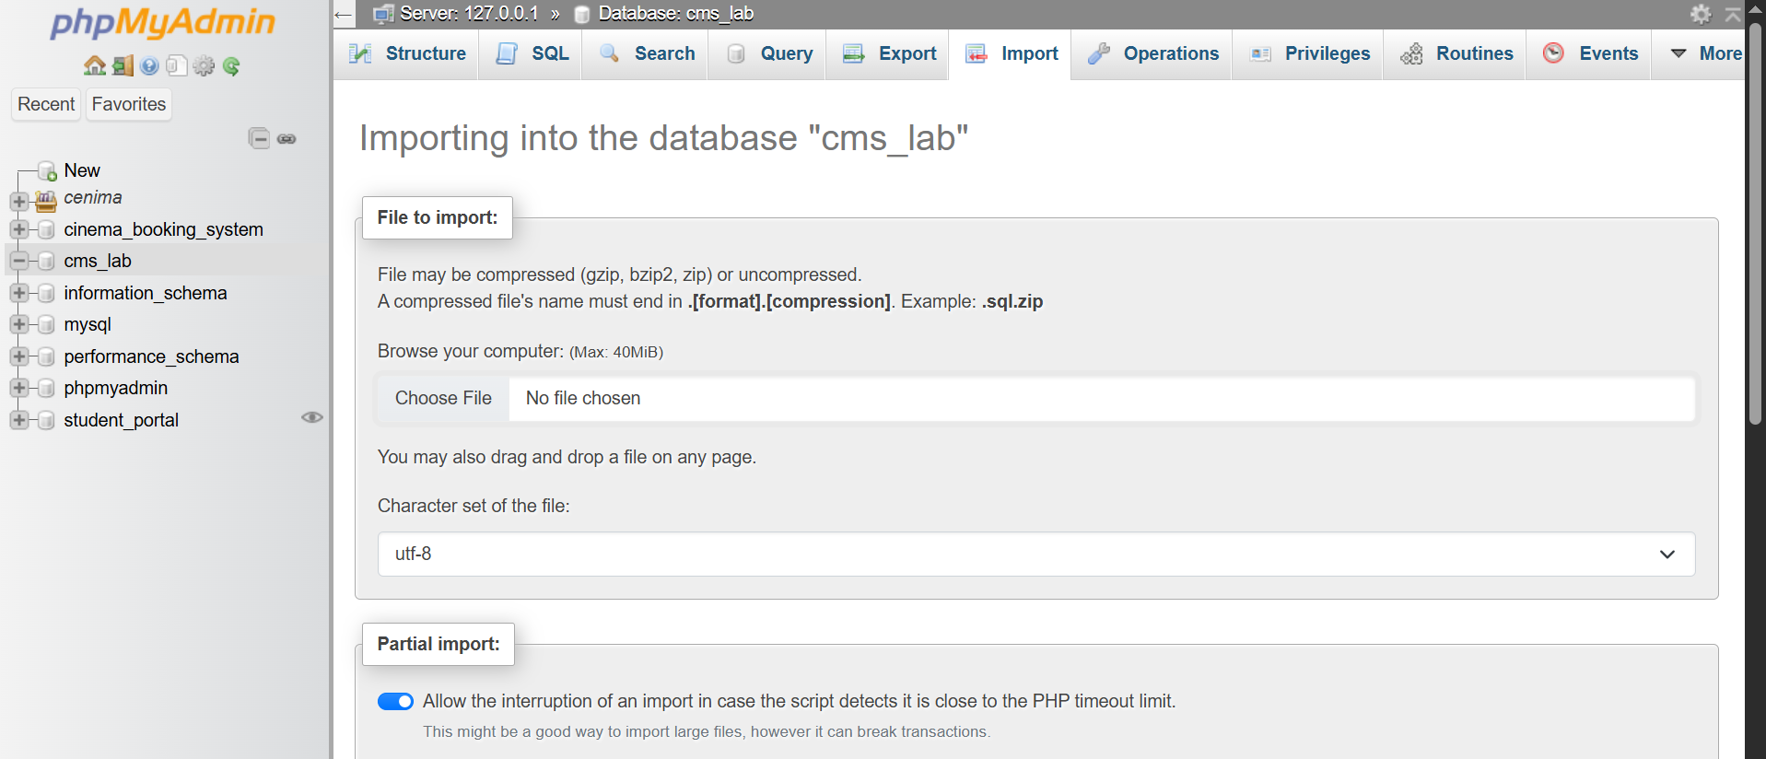

🧪 Lab Task 5: Install WordPress

Steps:
- Open browser
- Type: http://localhost/wordpress
- Select language
- Click Continue
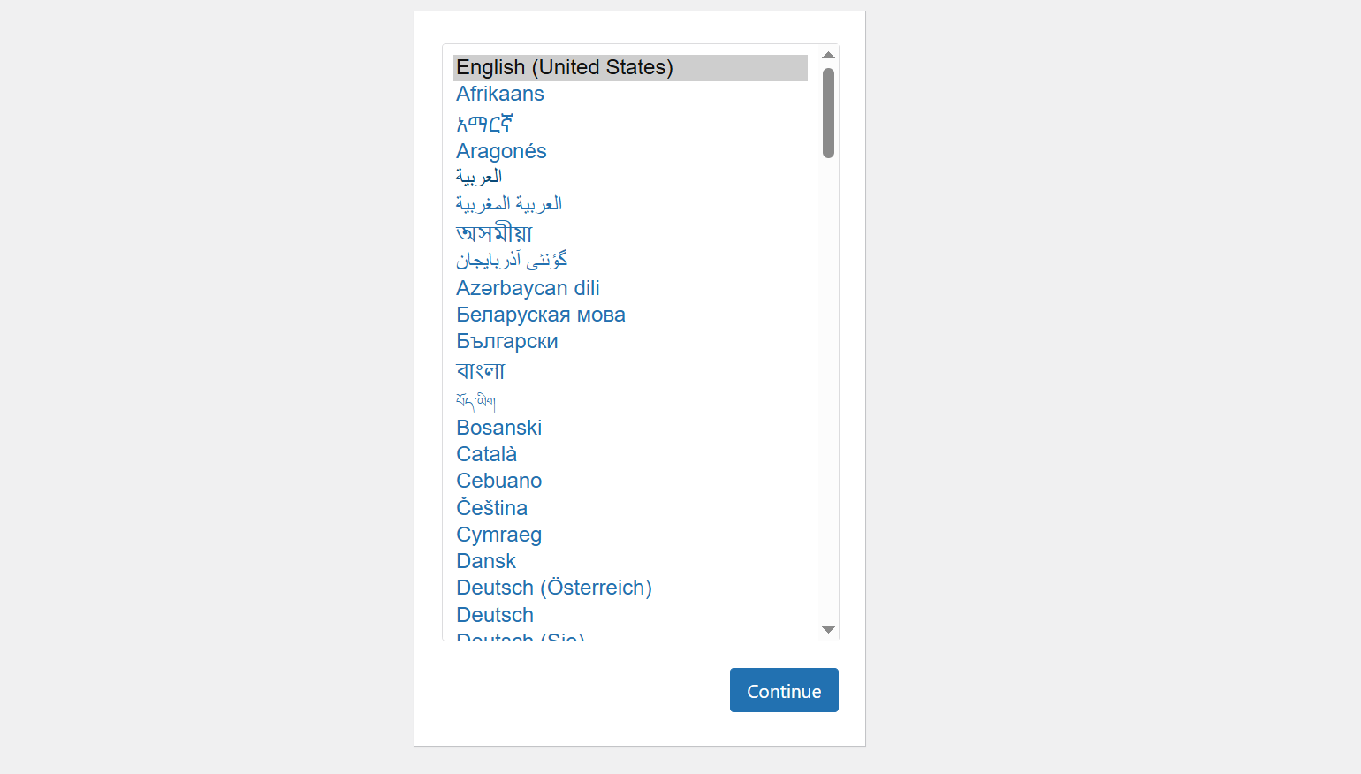
- Enter database details:
Field | Value
Database Name | cms_lab
Username | root
Password | (leave empty)
Server | localhost
- Click Submit → Run Installation
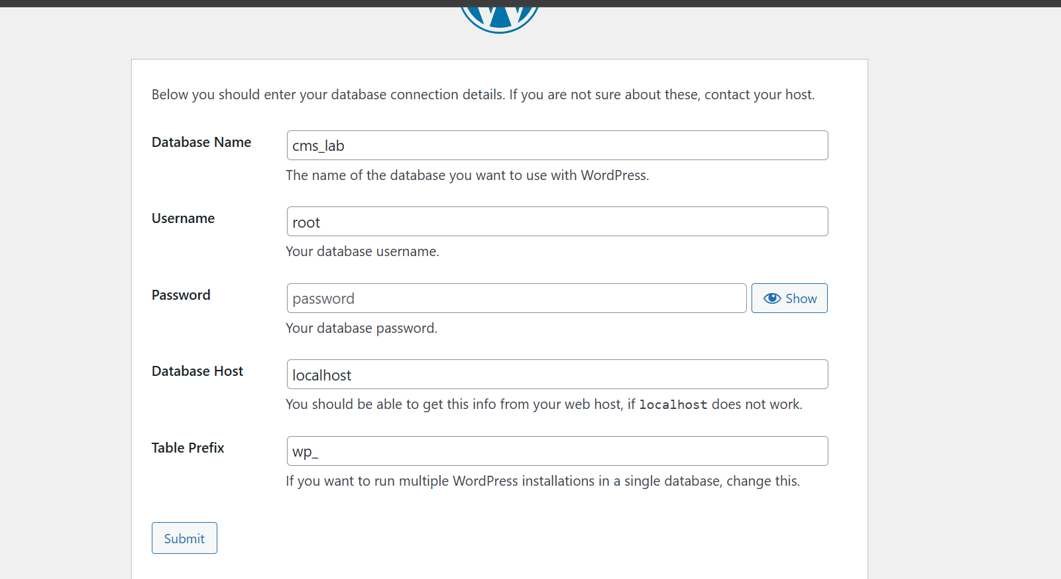

🧪 Lab Task 6: Create Admin Account

Fill the following details:
- Site Title: CMS Lab Website
- Username: admin
- Password: (Strong password)
- Email: your email
Click Install WordPress

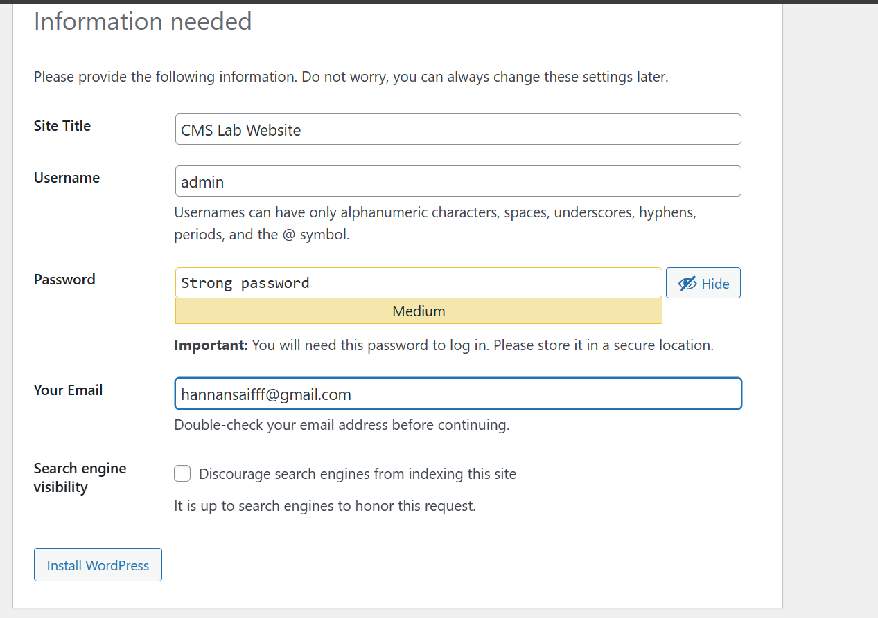

🧪 Lab Task 7: Explore WordPress Dashboard

After Login, Explore:
- Dashboard
- Posts
- Pages
- Appearance
- Plugins
- Users
- Settings
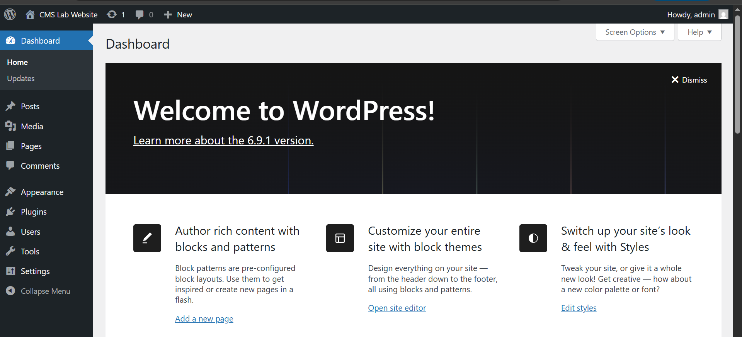

Task:
Write one-line purpose of each menu
• Dashboard – Gives an overview of your site’s status and quick access to updates.
• Posts – Create, edit, and manage blog posts.
• Media – Manage images, videos, and other uploaded files.
• Pages – Create and manage static pages like Home, About, Contact.
• Comments – View, approve, delete, or reply to user comments.
• Appearance – Customize your site’s theme, menus, widgets, and overall design.
• Plugins – Add, activate, deactivate, or manage plugins to extend functionality.
• Users – Manage user accounts and roles (admin, editor, subscriber, etc.).
• Tools – Access import/export tools and other maintenance utilities.
• Settings – Configure overall site settings like title, reading options, and permalinks.

🧪 Lab Task 8: Create First Post

Steps:
- Go to Posts → Add New
- Title: My First CMS Post
- Content: Write 3–4 lines
- Click Publish
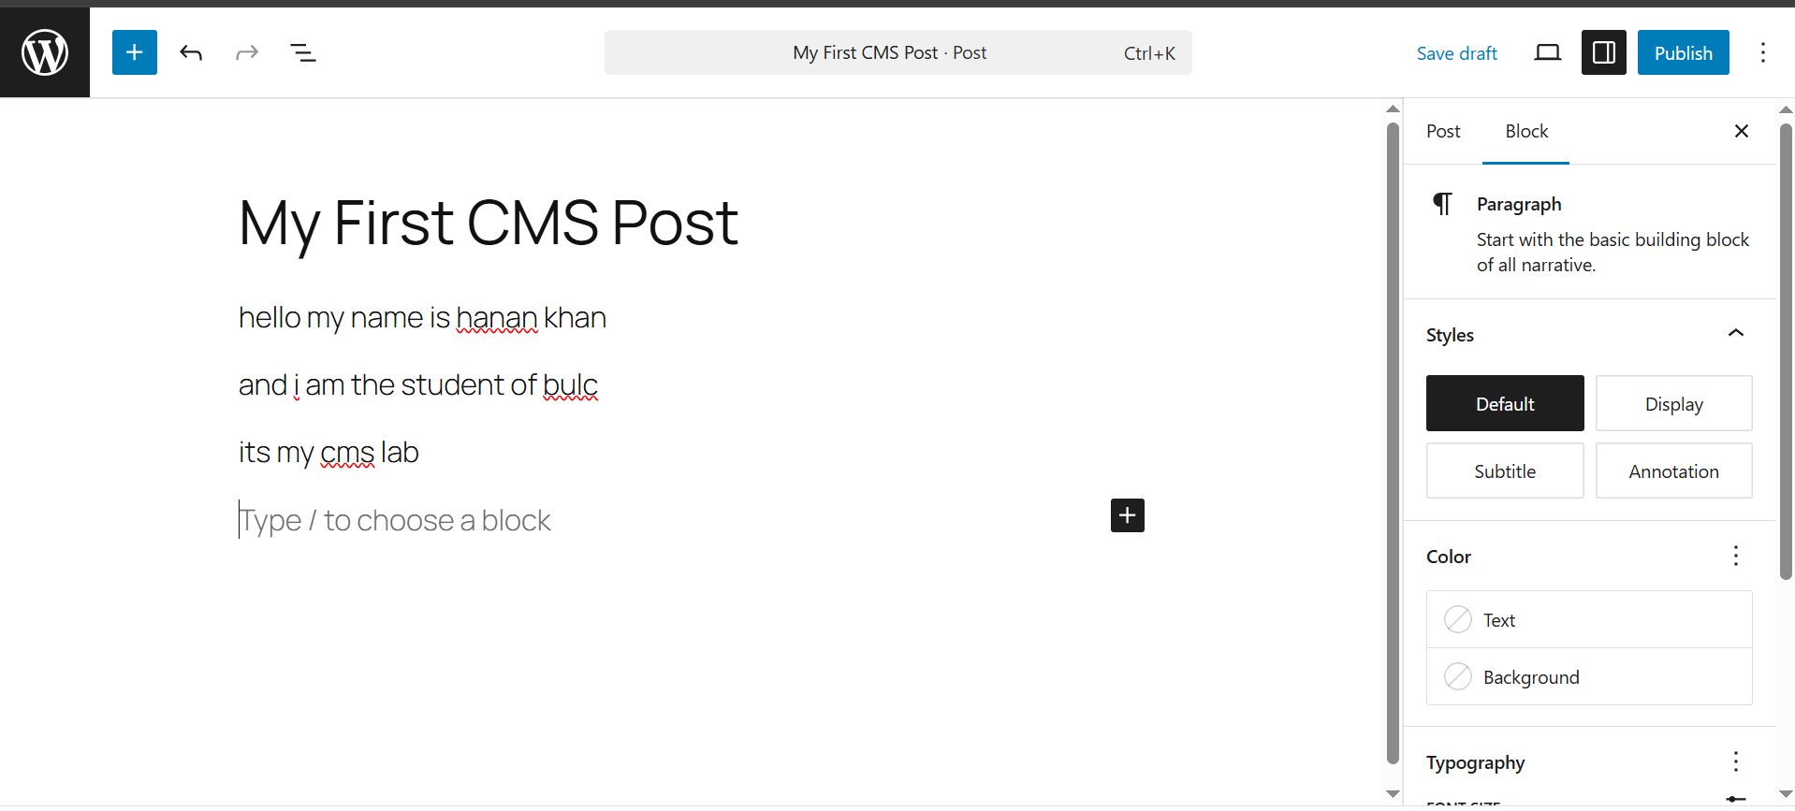

Output:
- Post visible on website homepage
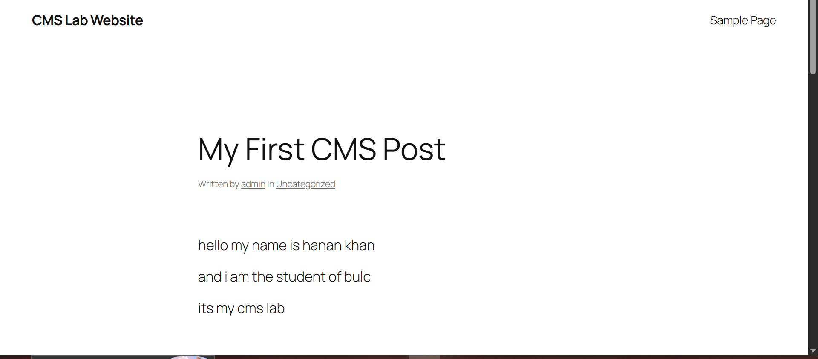

🧪 Lab Task 9: Create a Page

Steps:
- Go to Pages → Add New
- Title: About Us
- Write basic introduction
- Click Publish
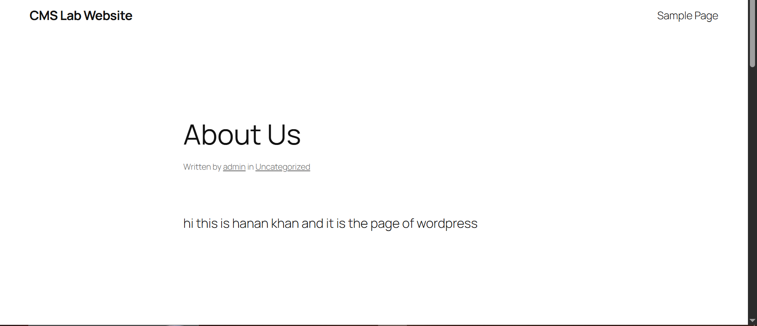

🧪 Lab Task 10: Change Website Theme

Steps:
- Go to Appearance → Themes
- Click Add New
- Install any free theme
- Activate theme

Observation:
Website appearance changes instantly
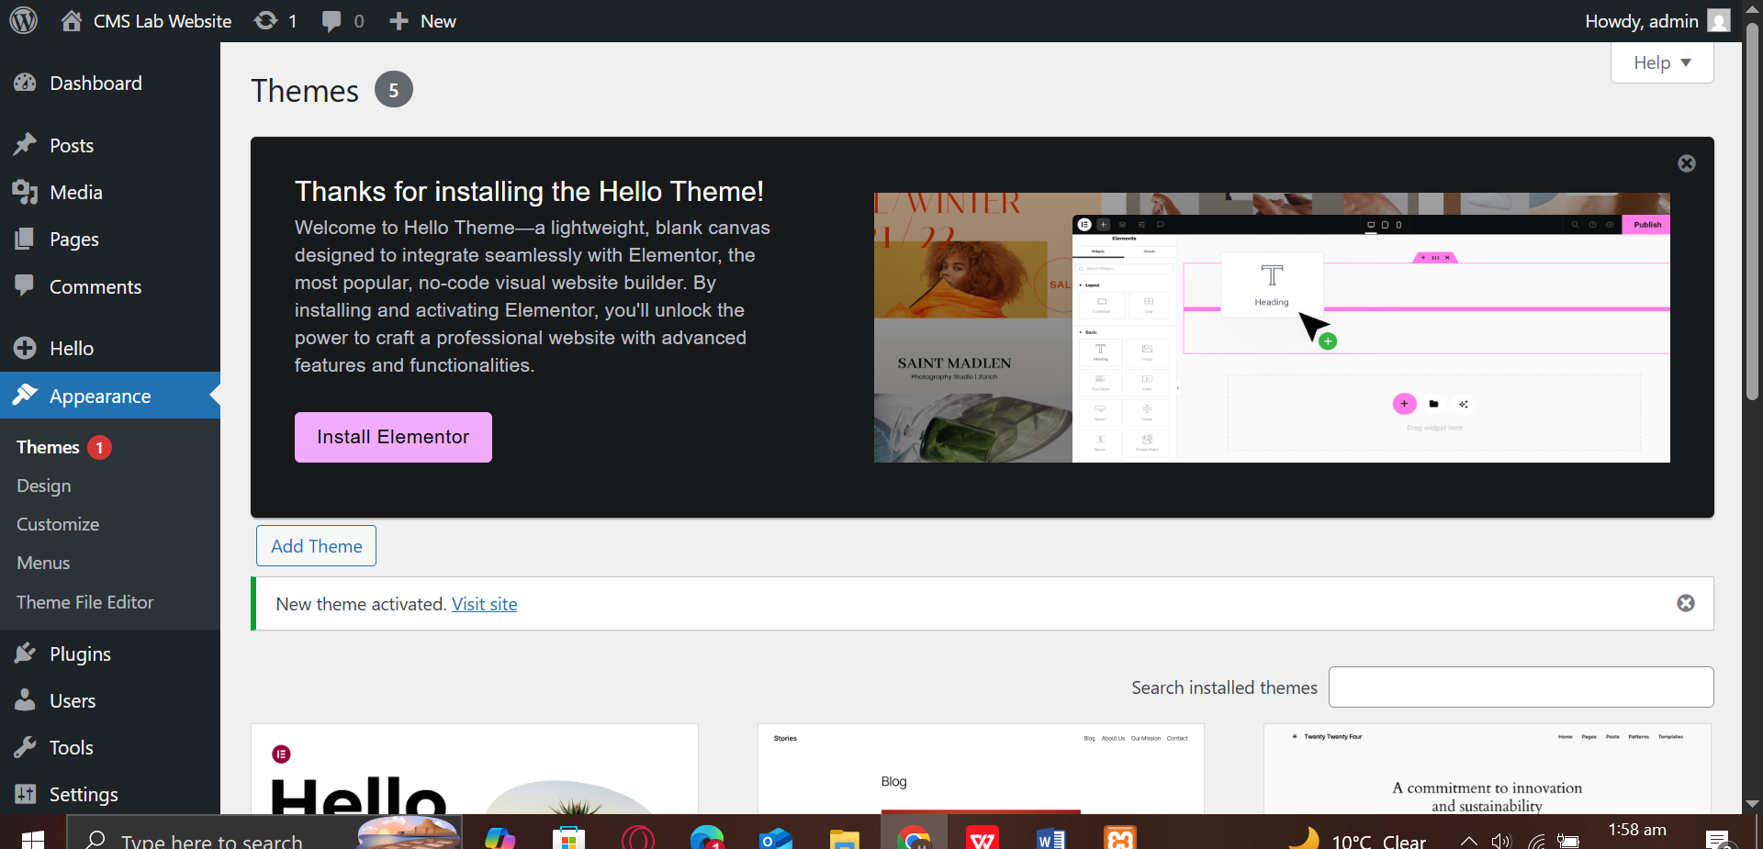

🔚 Conclusion
In this lab, students learned:
- CMS basics through practice
- Local server setup
- WordPress installation
- Content creation workflow
This lab builds the foundation for advanced CMS concepts.

📅 Next Lab Preview (Week 2)
- CMS Architecture
- Themes vs Plugins
- WordPress Settings
- User Roles

